***Assignment -2***

***Andrew John***

***18BEC1278***

* **Develop an "Automatic garage door opening system". Use an Ultrasonic sensor to detect if there is a vehicle in front of the garage. If any vehicle is detected, open the garage door (rotate the servo motor) for some time and close it.**

**CODE:**

*#include<Servo.h>*

*Servo s;*

*int trig = 8;*

*int echo = 9;*

*int getDist()*

*{*

*digitalWrite(trig,LOW);*

*digitalWrite(trig,HIGH);*

*delayMicroseconds(10);*

*digitalWrite(trig,LOW);*

*float dur = pulseIn(echo,HIGH);*

*float dis = (dur*0.034)/2;*

*return dis;*

*}*

*//Open the Door*

*void open()*

*{*

*for(int i=0;i<=180;i++){*

*s.write(i);*

*delay(100);}*

*}*

*//Close the Door*

*void close()*

*{*

*for(int j=180;j>=0;j--){*

*s.write(j);*

*delay(10);*

*}*

*}*

*//Initializing the Pins*

*void setup()*

*{*

*s.attach(4);*

*pinMode(trig, OUTPUT);*

*pinMode(echo, INPUT);*

*Serial.begin(9600);*

*}*

*void loop()*

*{*

*int dis = getDist();*

*Serial.print("Distance in cm: ");*

*Serial.println(dis);*

*if(dis < 50)*

*{*

*Serial.println("Distance is lesser than 50cm");*

*Serial.println("---Opening the Garage Door---");*

*open();*

*Serial.println("---Waiting for 5 secs---");*

*delay(5000);*

*Serial.println("---Closing the Garage Door---");*

*close();*

*}*

*else*

*{*

*Serial.println("Distance is greater than 50cm");*

*s.write(0);*

*}*

*Serial.println("---Delay of 5 secs---");*

*delay(5000);*

*}*

**CIRCUIT DESIGN:**

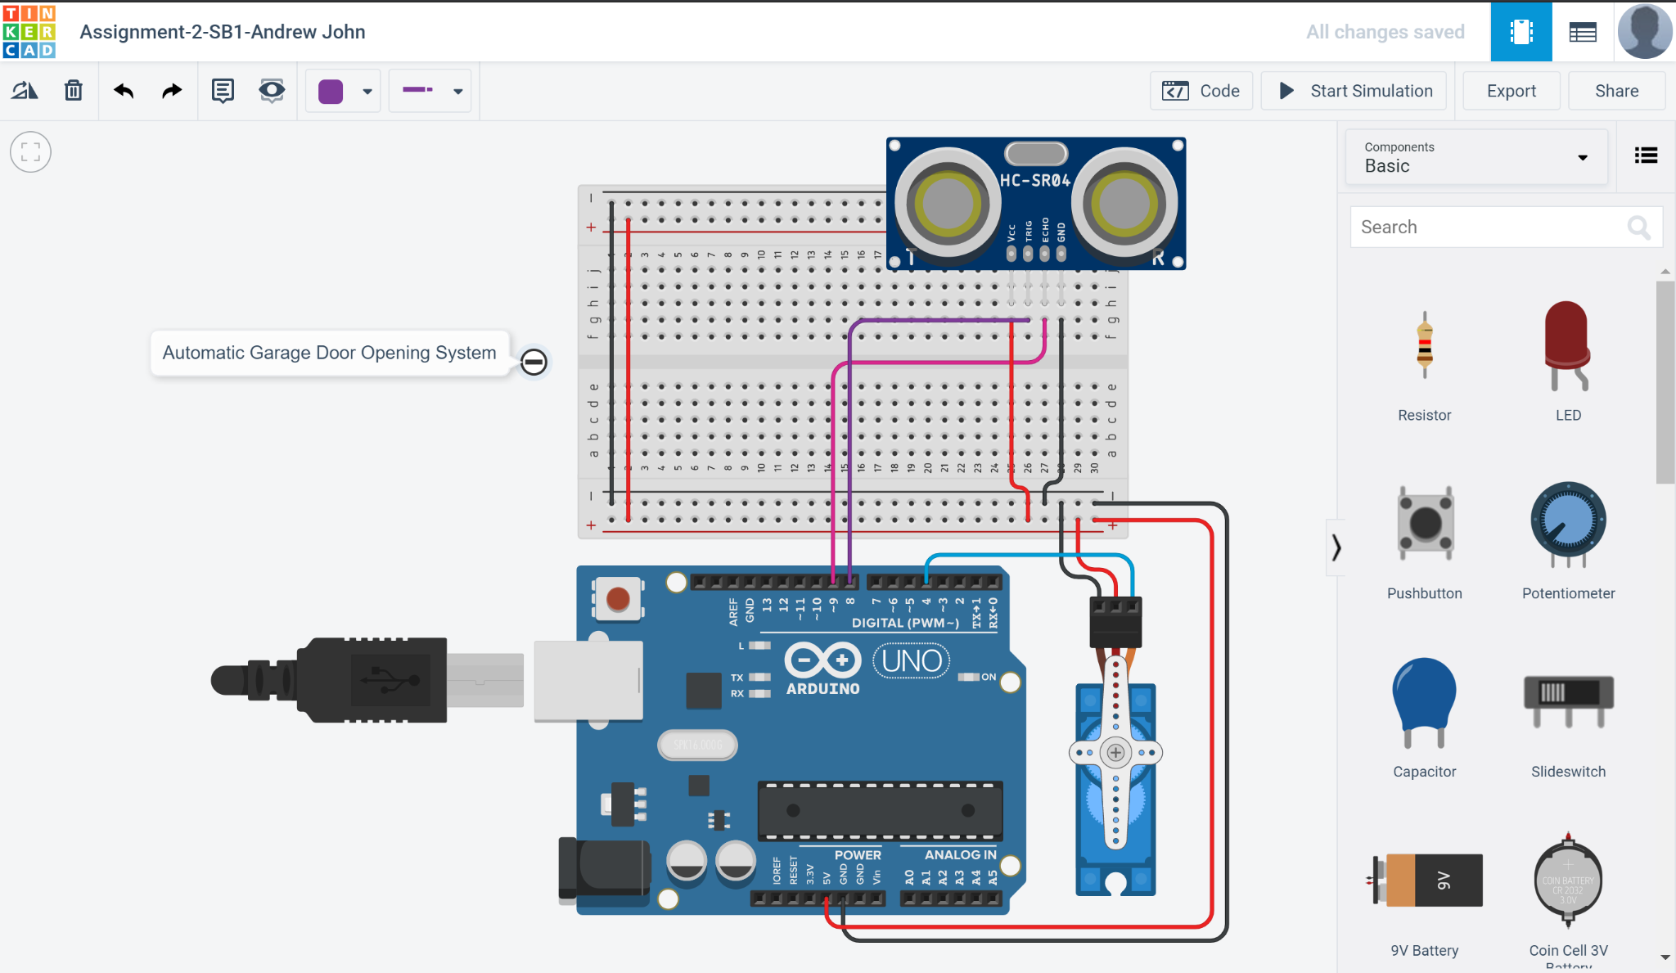

**OUTPUTS:**

1. **Opening garage door for distance greater than 50cm.**

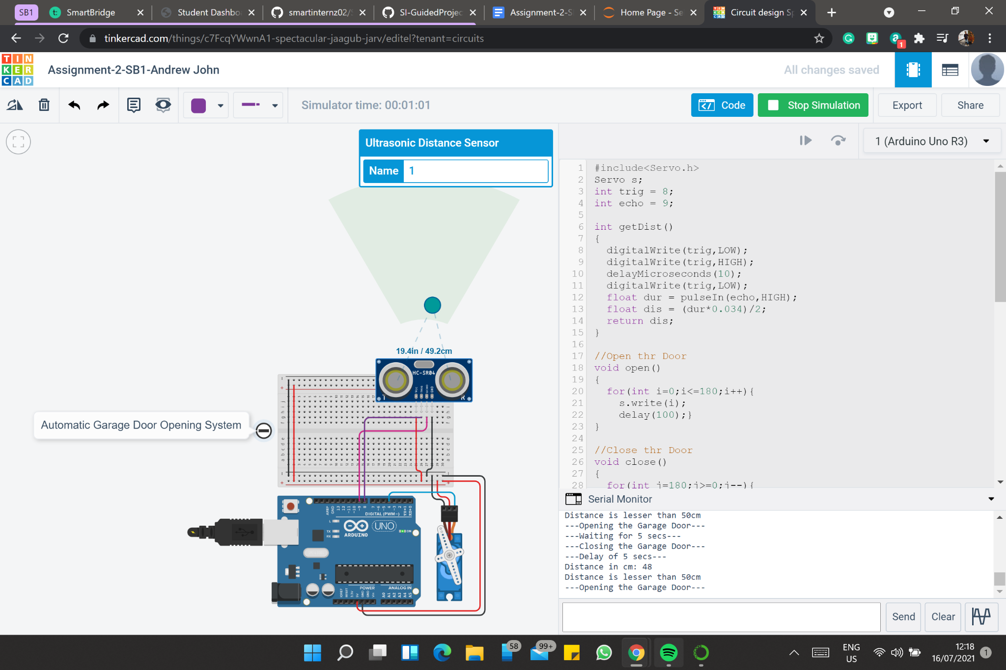

*Fig-1: Opening the Garage Door*

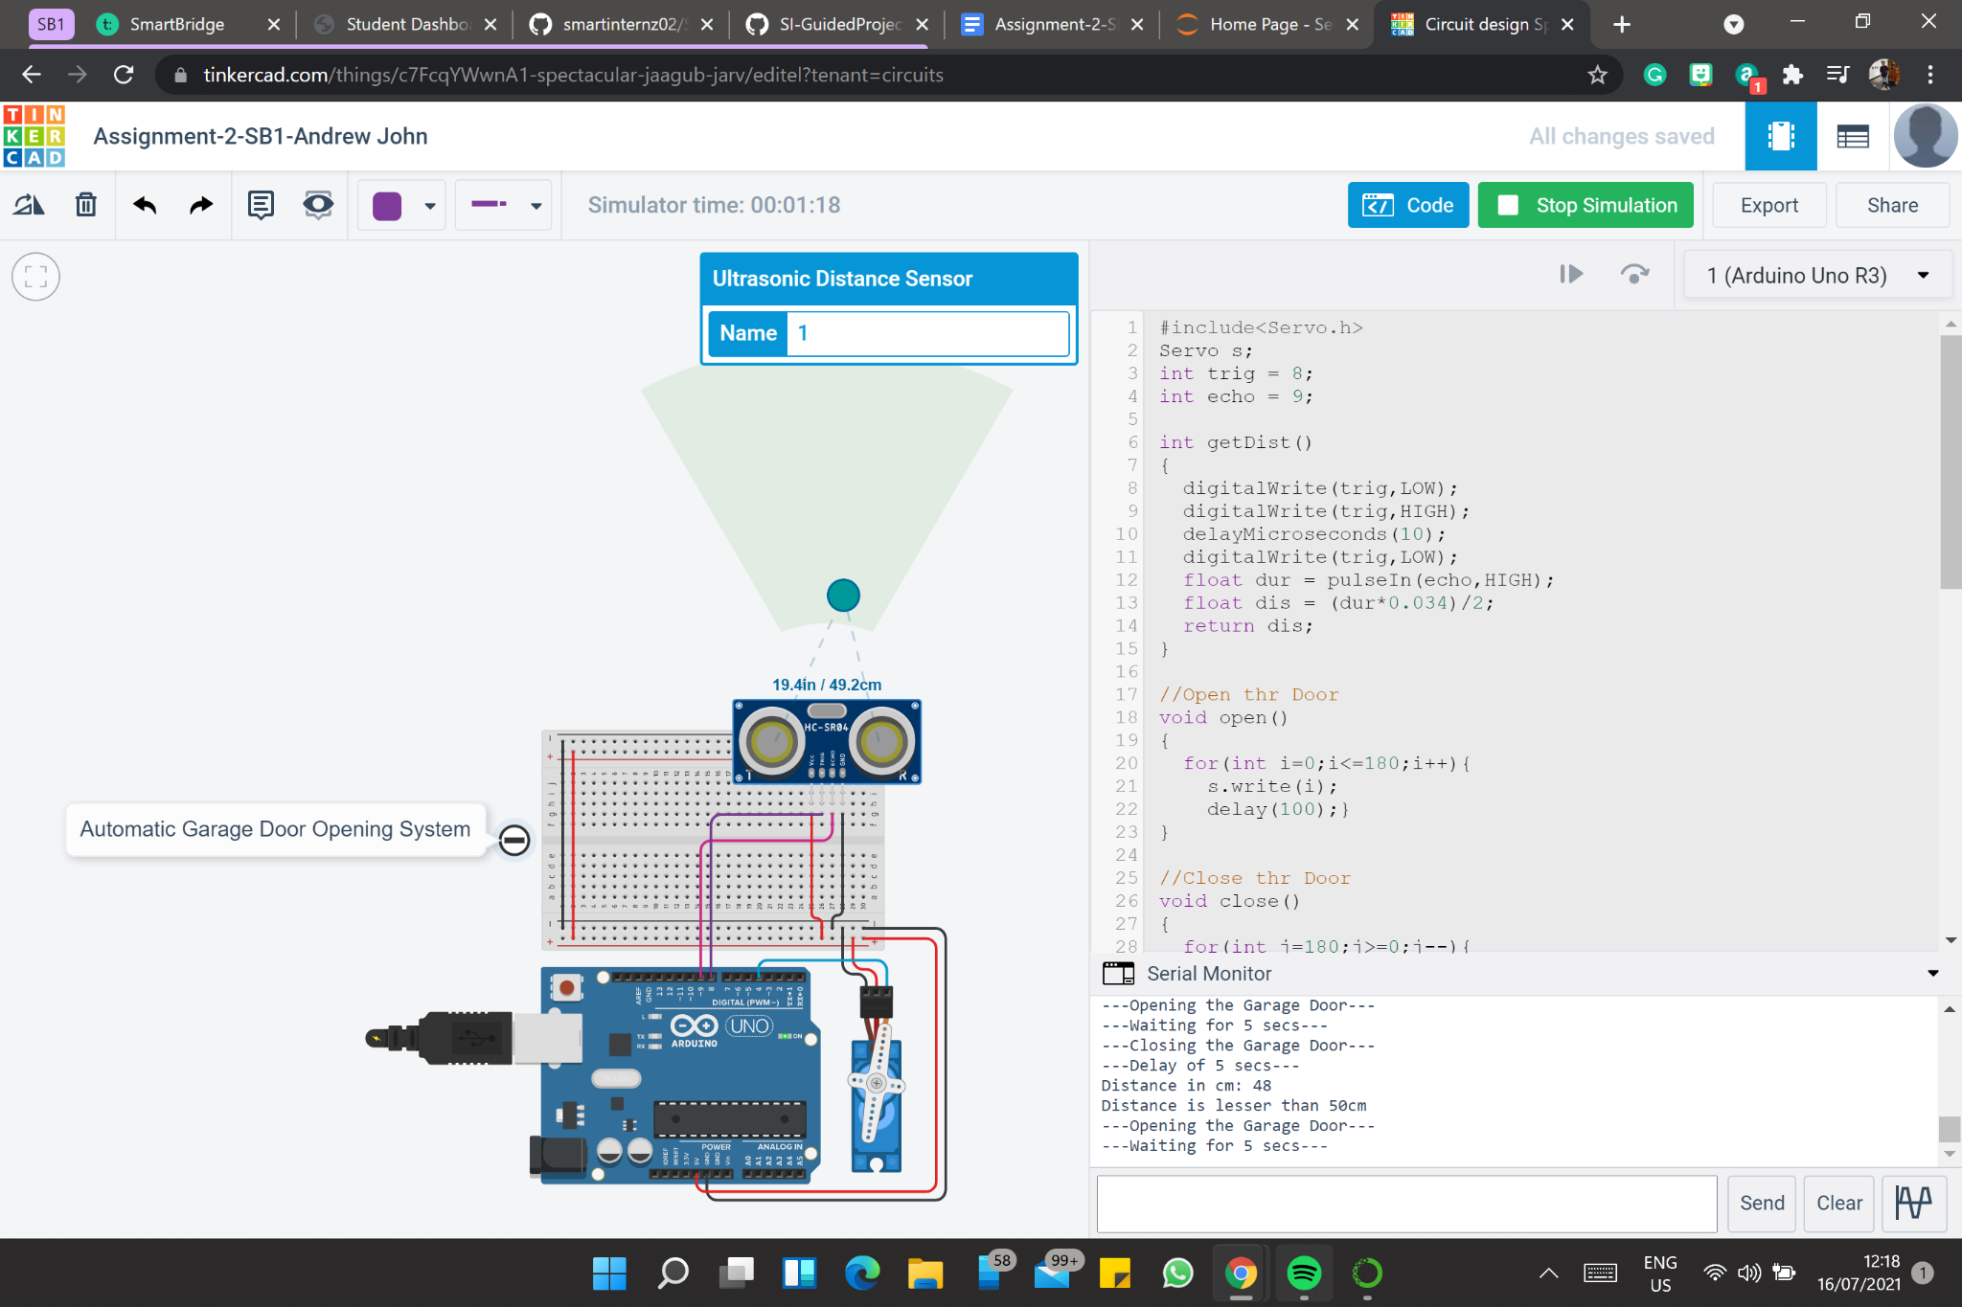

*Fig-2: Waiting for 5 seconds*

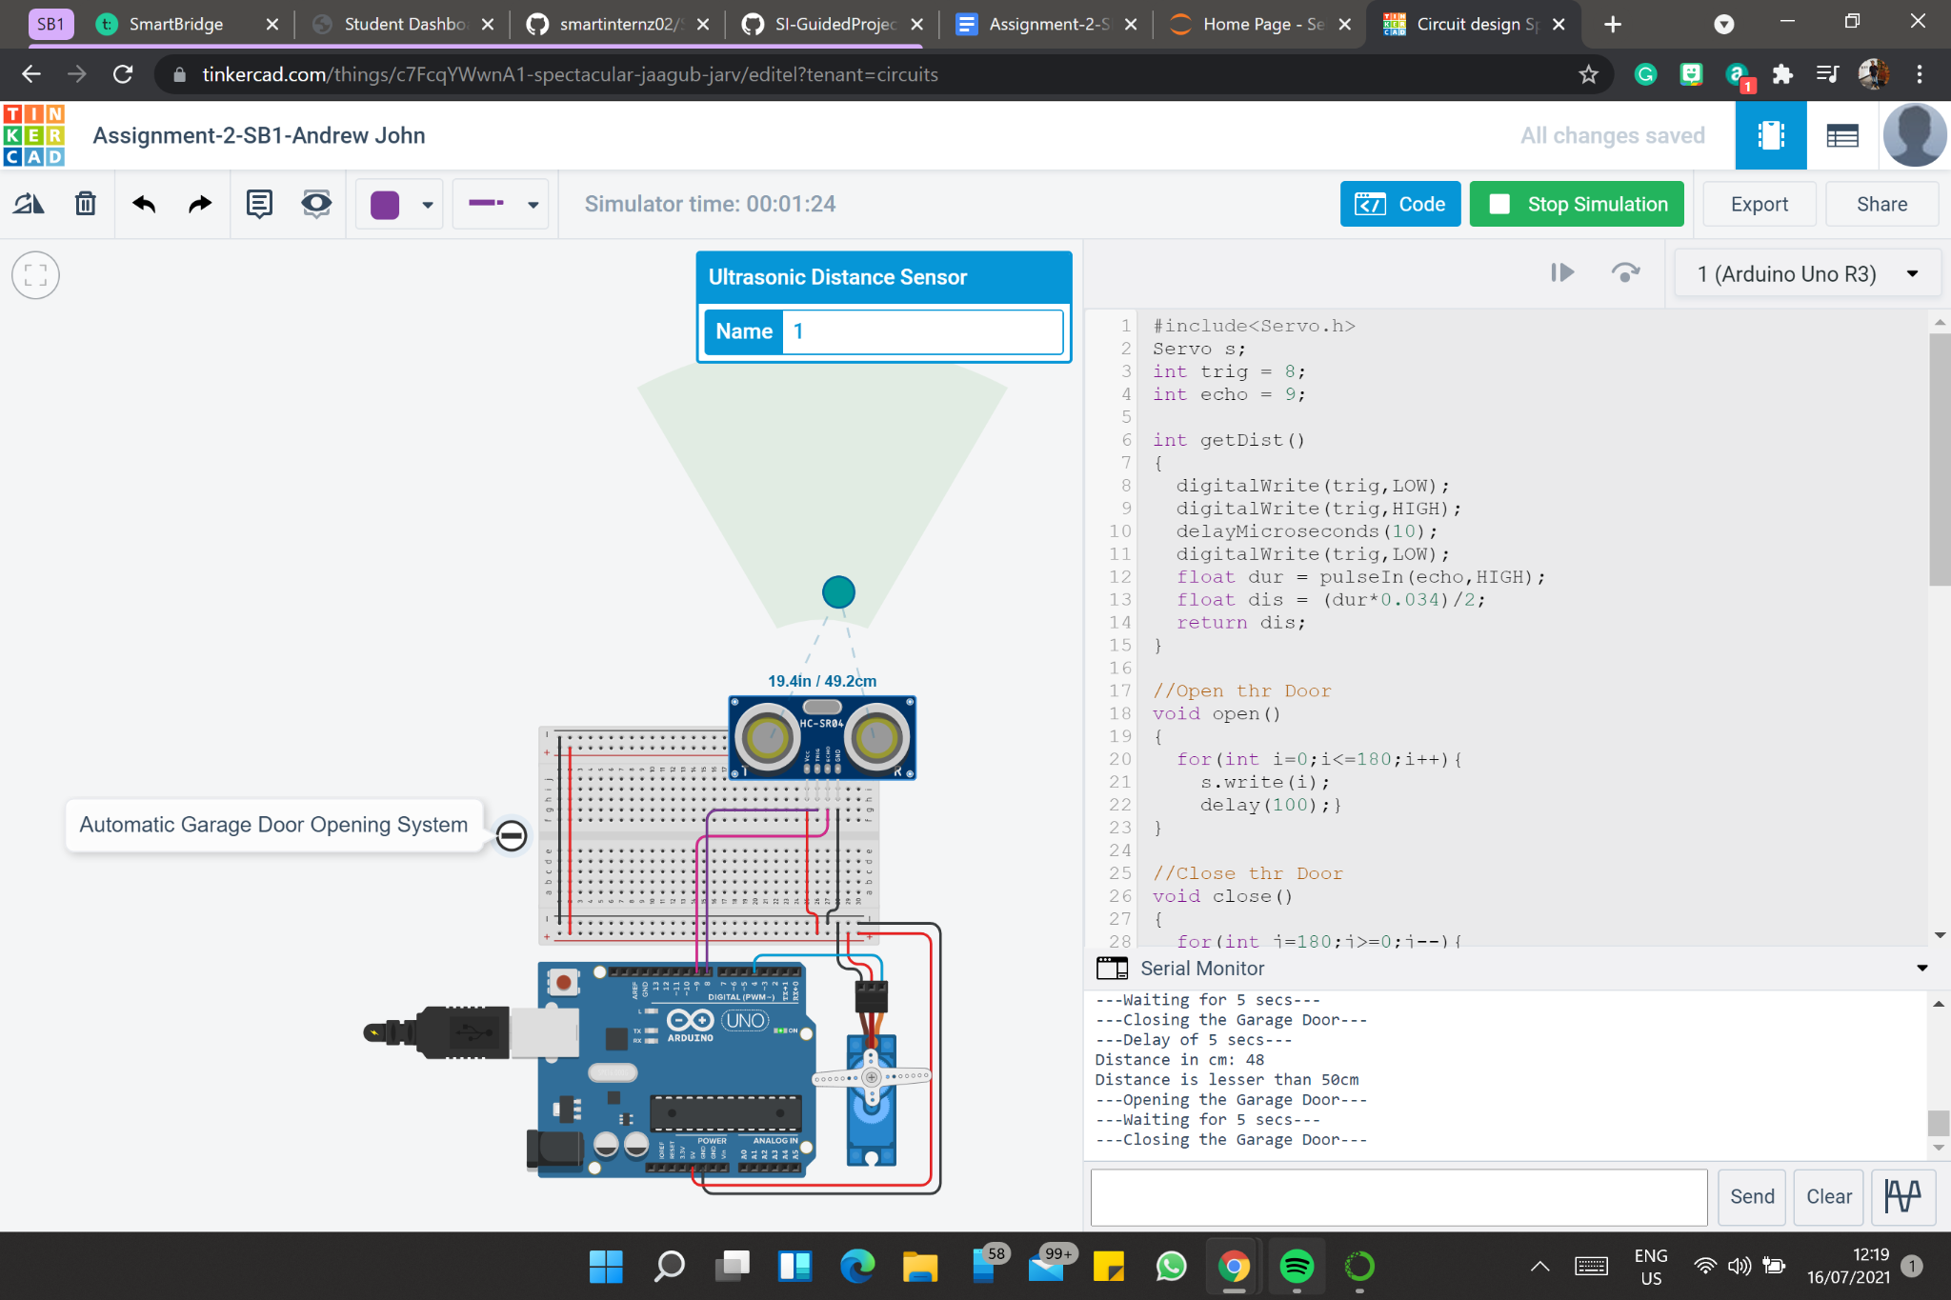

*Fig-3: Closing the Garage Door*

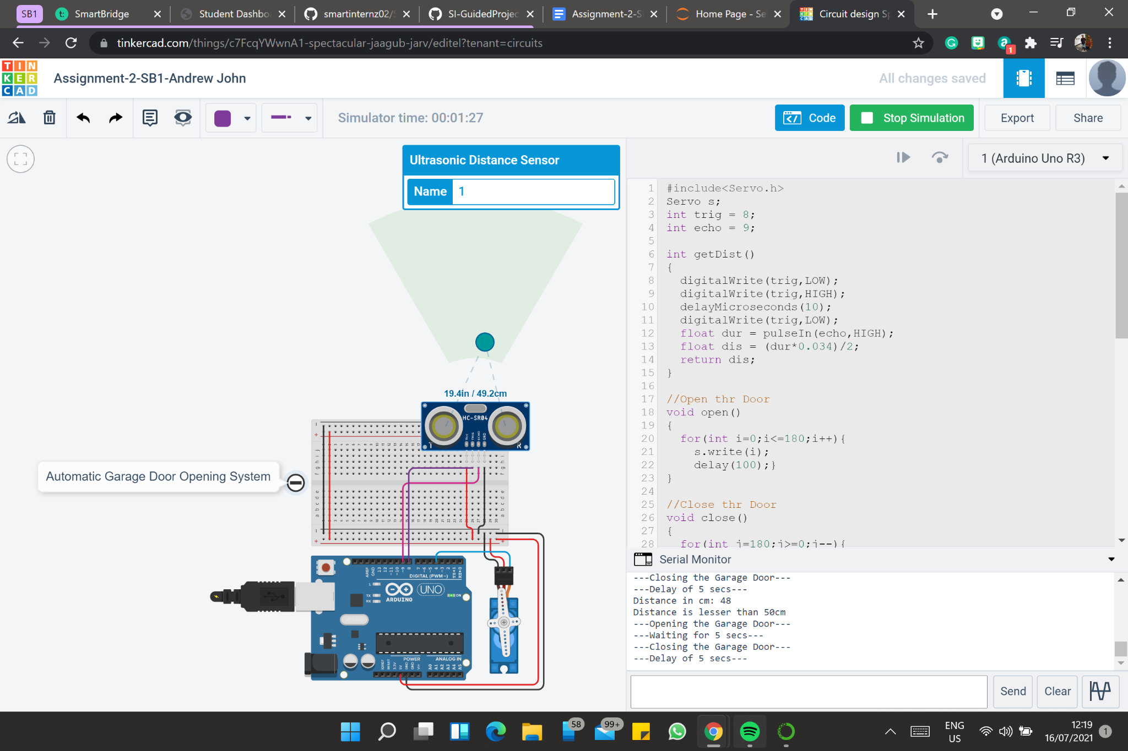

*Fig-4: Delay of 5 seconds*

1. **Closing garage door for distance lesser than 50cm**

